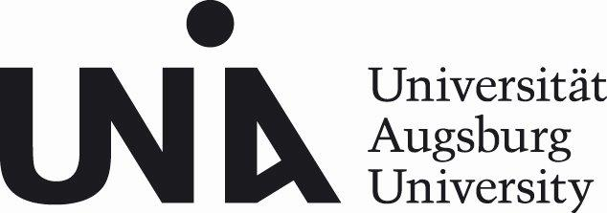
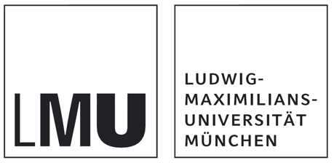

Call for Applications
Augsburg-Munich International Doctoral Program
Rethinking Environment: The Environmental Humanities and the Ecological Transformation of Society

Deadline: January 31, 2025
The University of Augsburg and Ludwig Maximilian University of Munich invite applications for

12 Doctoral Positions (m/f/d)
in their International Doctoral Program (IDK) funded by the Elite Network of Bavaria. The positions are to be filled for 65 % of regular working hours in an employment relationship initially limited to two years, with the option of extending the temporary employment for an additional two years, provided that the relevant requirements are met. If the personal and pay scale requirements are met, remuneration will be in accordance with pay group E 13 TV-L. The IDK starts on October 1, 2025.
Based at the University of Augsburg (Environmental Science Center, WZU) and Ludwig Maximilian University of Munich (Rachel Carson Center, RCC), this Environmental Humanities program offers a unique opportunity to pursue a doctoral degree in an international and interdisciplinary setting and under the supervision of faculty from both universities. We are looking for applications from fields such as American Studies, Anthropology, Communication Science, Environmental Economics, Environmental Ethics, Geography Education, History, Human Geography, Iberian & Latin American Studies, Philosophy, and Theology.
Under the IDK’s broad theme “Rethinking Environment. The Environmental Humanities and the Ecological Transformation of Society” we invite projects working on a variety of scales ranging from the global to the local that align with the program’s focus on socio-ecological transformation. We particularly welcome topics that relate, but are not exclusive to:
- Landscapes, Resources, and Infrastructures
- Environmental Education and Communication
- Environmental Knowledges and Justice
- Environmental Narratives and Representations
We invite research on all world regions and applications from across the world. Languages are English and German; non-native speakers are expected to acquire a working level of German within the first two years of the program. The IDK is looking for candidates willing to engage in interdisciplinary dialogue. Active participation in the program and residency in the region are expected.
Applicants must have a completed degree (M.A., M.Sc. or equivalent) with very good grades. Submissions can be made via our online application form and need to include:
- The filled out online application form
- a letter of motivation (400 words max.)
- a project proposal (max. 1500 words, including abstract)
- a short CV (max. 2 pages)
- copies of university degree(s)
- final thesis or other single-authored text (e.g. term paper, peer-reviewed article, book chapter)
Reflecting the participating universities’ commitment to diversity, we encourage applications from underrepresented groups and regions. We especially welcome applications from women and LGBTQI+ persons, and explicitly invite people with chronic illnesses and disabilities to apply. Our universities stand up for compatibility of family and professional life. In the case of equally qualified candidates, applicants with a disability/chronic health condition will be given preference. For more information see https://www.uni-augsburg.de/de/verantwortung/gender-equity-diversity/ and https://www.lmu.de/de/die-lmu/arbeiten-an-der-lmu/zusaetzliche-angebote/diversity/
The application may be written in English or German and must be submitted as one PDF file (up to 8 MB) via our application form at
https://www.uni-augsburg.de/en/forschung/einrichtungen/institute/wzu/studium/idk/application24/
The application form, along with a list of FAQs, can also be found here: https://www.uni-augsburg.de/de/forschung/einrichtungen/institute/wzu/studium/idk/
The Deadline is January 31, 2025.
Preselected candidates will be invited for individual interviews starting March 2025.
More information on the program, advisory team, research topics of the first cohort can be found on our website https://rethinking-environment-idk.de/
For questions please contact: PD Dr. Kirsten Twelbeck (twelbeck.idk@wzu.uni-augsburg.de)
Please note that only the German version of the job advertisement is legally binding. It can be found on the website: https://www.uni-augsburg.de/de/jobs-und-karriere/stellenangebote. This English translation of the job advertisement is provided to help you understand the original German one.

